|  |  |
| --- | --- |
| Procedure:  **QP-111** | Pages: **4** |
| Printed:  **8/22/2024** | Released: **12/05/2023**  Rev. Num: **9** |
| Authorized By:  **Quality Assurance Manager** | |

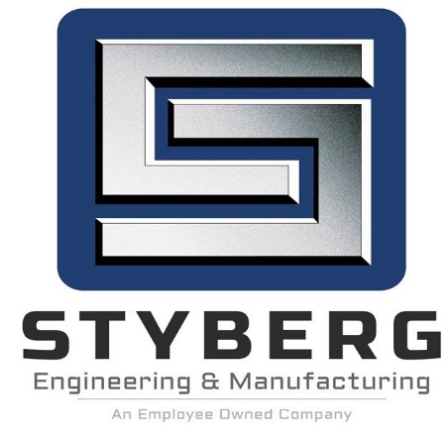

**DOCUMENT CONTROL – INTERNAL**

1. Purpose and Scope

**PURPOSE**

To define the process used to ensure product design documents are complete, accurate, and distributed to the appropriate locations.

**SCOPE**

This procedure applies to the preparation, approval, issue, revision, and recall of documents as follows:

1. Engineering design drawings issued by E.C. Styberg Engineering Co. (CAD or

Manual)

1. Tool and Fixture design drawings (CAD or Manual)
2. Manufacturing instructions, including process parameters, manufacturing process Instructions and packaging requirements
3. Inspection instructions and records
4. Material and process specifications issued by E.C. Styberg Engineering Co. or its

customers

1. Quality System Documents: Policies, Procedures, Work Instructions and Control

Plans

1. Definitions

**Documents**: Written or electronic matter that provides information or evidence that

serves as an official record. Examples: Manufacturing Instruction Sheets, Controlled

Forms and Inspection Checklists.

1. Process Owners

**Quality Assurance Manager**

**Process Designees: Project Engineer**

**All Department Supervisors**

**Process Owner (or Designee)/Document Originator**

**Quality Systems Coordinator**

**Industrial Engineer**

1. **Procedures**
2. **Project Engineer**

**Maintains Master Folder**

The Project Engineer maintains all tooling designs and reviews them on an as needed basis for the purpose of identifying where updates or revisions are needed. All tooling and fixtures are listed on the tooling log within the master folder of the associated part number for which they are used, and a record is maintained online in the ERP System program.

1. **Industrial Engineer**

**Manufacturing Instruction Sheets**

All creation and revising of these documents shall be done by the I.E., department only. I.E., maintains a master list of all Manufacturing Instruction Sheets and revisions. INS-9000 contains instructions for the control of these documents.

1. **Process Owner/Document Originator**

**Document Change/Addition**

Requests for additions and/or changes to policies, procedures, work instructions or forms that affect the quality system will be directed to the Quality Systems Coordinator, who facilitates and maintains revisions of all QMS documents (as previously listed).

**Documentation update**

Documents associated directly with part numbers will require additional coordination. Documents such as Manufacturing Routings, Manufacturing Instruction Sheets (MIS), Control Plans and Inspection cards will require sign-off when changes are made. The holder of the document(s) will maintain a record of all changes and the balance of all documents under their control. When changes are made, this information will be forwarded to the appropriate individuals and documents associated should be changed where applicable. All documentation relating to parts should be consistent.

**Documents that affect Rolls Royce**

All documents that affect Rolls Royce must also be copied to the SRP Manuals. This is handled by the QSC.

1. **Quality Systems Coordinator**

**Obtains Designated Approvals**

The Quality Systems Coordinator will prepare and circulate all changes/additions to the quality system, to all departments that are affected.

**Obsolete Documents**

When a document has been revised the obsolete copy of the document should be destroyed immediately. Hard copies of the document should be ripped in half and placed in the document recycle center, and electronic copies should either be moved to the Obsolete folder (if exists) or deleted from the folder.

**Verifies, Updates and Distributes Final Copies**

Upon approval the QSC will distribute final updated copies to the Electronic Folder for all policies, procedures, work instructions and forms, hardcopies to all appropriate departments without computer access and update master lists for Forms as needed.

**Documents that affect Rolls Royce**

All documents that affect Rolls Royce must also be copied to the SRP Manuals.

1. **References**

**5.1 Related Procedure**

Document Control – External Documents QP-112

**5.2 Reference Documents**

Creating, Updating and Controlling Manufacturing Instruction Sheets

INS-9000

1. **Records**

Request for Document Approval DOC-101 Retain Min. of 3 years.

Master Folder MAS Folder Retain life of Job + 1 year.

1. **Policy References**

Document Control

1. **Revision History to Procedure QP-111**

|  |  |  |  |
| --- | --- | --- | --- |
| **Chg. No.** | **Date** | **Rev.** | **Change Description** |
| 1 | 2/13/1998 | 0 | Creation of Document |
| 2 | 5/24/2000 | 1 | Changed retention time period for the Master Folder under section 6 'Records. |
| 3 | 9/13/2007 | 2 | Added 4 Document changes |
| 4 | 6/1/2011 | 3 | Added 4 “All documents that affect Rolls Royce must also be copied to the Lead person of the SRP's". |
| 5 | 4/3/2012 | 4 | Rev 1 Added to Section 4  Documentation update. Documents associated directly … should be consistent. |
| 6 | 8/19/2013 | 5 | Rev. 2 Added to section #4  Obsolete DocumentsWhen a document …deleted from the folder |
| 7 | 1/17/2014 | 6 | Rev. 3 Removed “under gages” from last sentence paragraph #4  Corrected spelling paragraph #4 “computer access” |
| 8 | 3/15/2019 | 7 | Rev. 4 3/15/19 (Initiator: Erik W.) Updated Sec. 3 to include I.E. As a process designee. Changed Sec. 4 owner from ‘Departmental Supervisor’ to ‘I.E.,’ Updated wording in sec. 4 to reference INS-9000 for M.I.S. Control instruction and eliminated sentence about supervisors calling for MIS’s (not appropriate QP for that, described in INS-9000. Added INS-9000 to sec. 5 ‘reference Documents’. |
| 9 | 12/05/2023 | 8 | Changed Document Type from Instruction to Procedure.  Section 8-Removed “of”, added “History to Procedure.”  Added-Revised Styberg Logo, Revision History Block,  Changed revision number from 4 to 9 to reflect correct change history  4 changed from “Oracle” to “ERP System” |